Some Applications (Some of them overlap):

* Statistics
* Data interpretation, machine learning etc.
* Forecasting (Weather etc.)
* Actuarial Sciences (Insurance etc.)
* Quality Control
* Stochastic
* Only the applications of conditional probability is hard to list
* many more…

Regression: A way to “predict” future

CURVE FITTING:

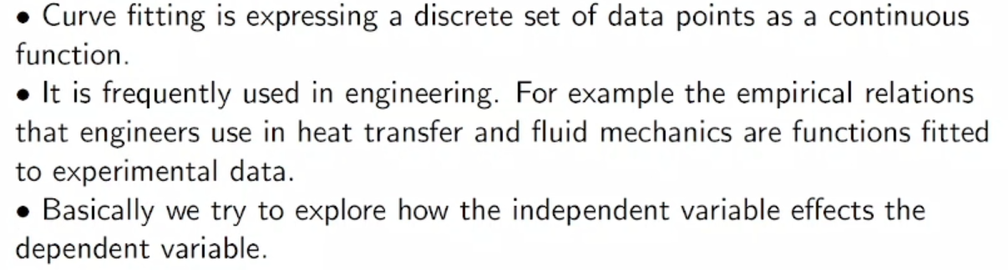

Measure enough time and predict the future.

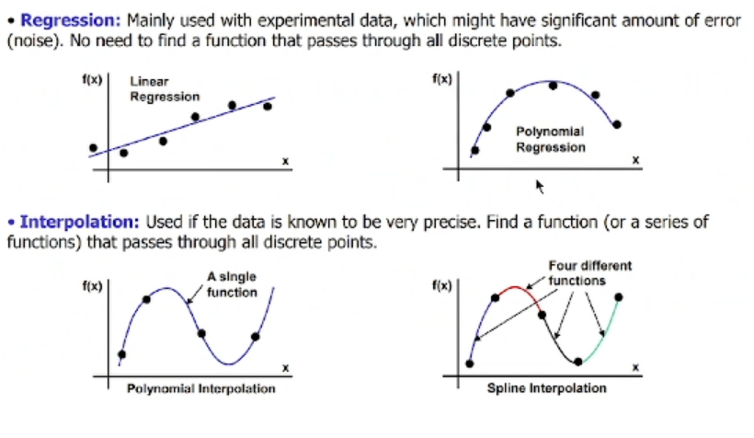

x is independent variable. When you change it, f(x) will change.

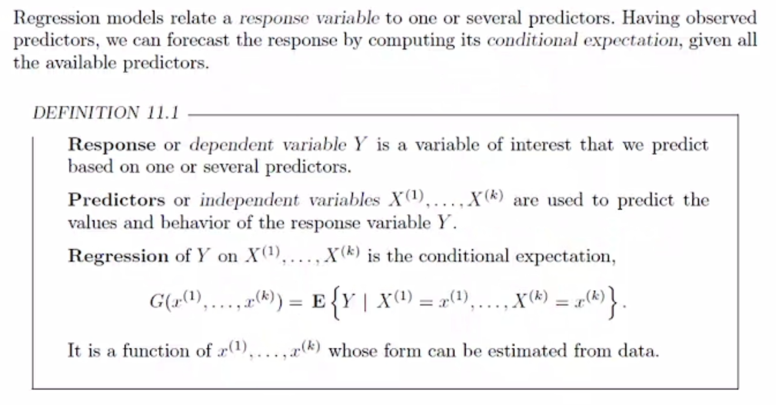

Response variable is dependent variable.

Predictor is independent variable.

G regression function (estimation function) gives us the relation. The function of variables which is expected value of Y when we know values of X variables.

Example:

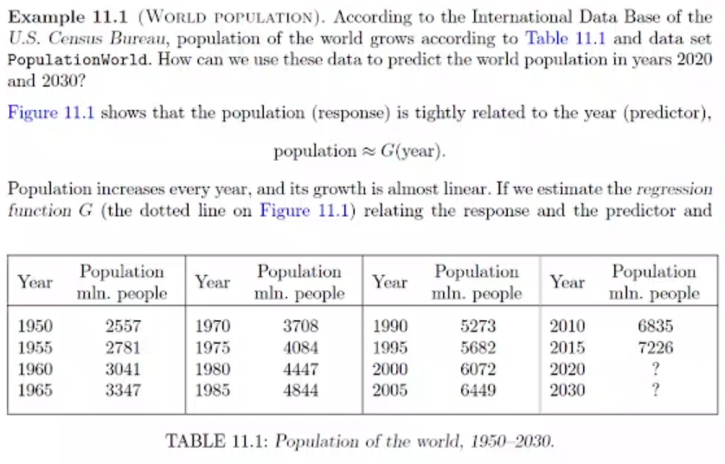

independent variable 🡪 year

dependent variable to year 🡪 population

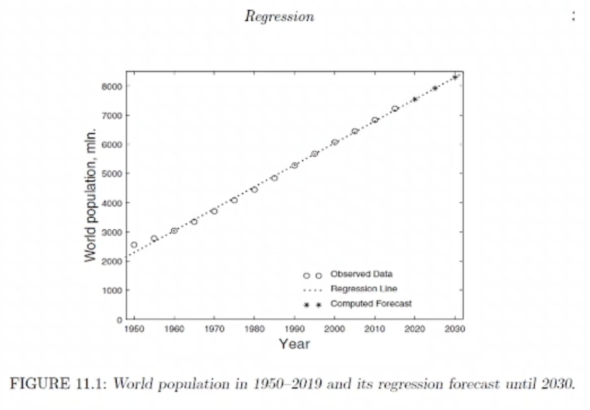

Regression line is the function G that we are trying to find.

Equation for line is ax+b

Another example:

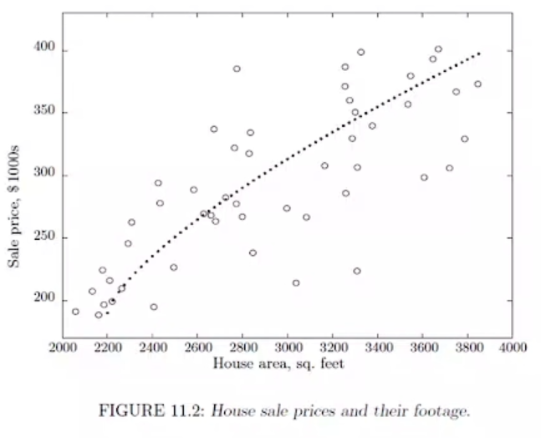

Least Squares Estimation

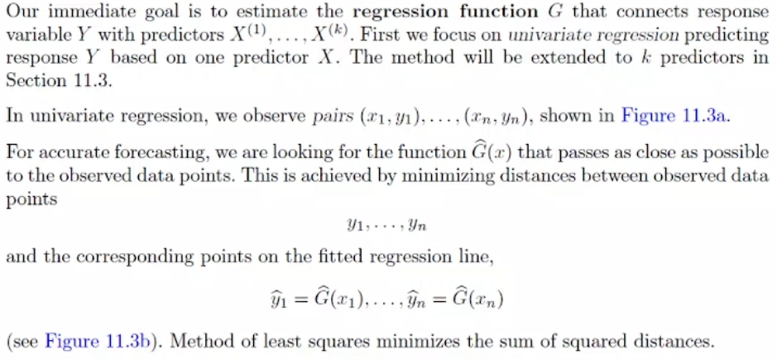

G is connection between X and Y variables.

$\hat{G}$ is estimated.

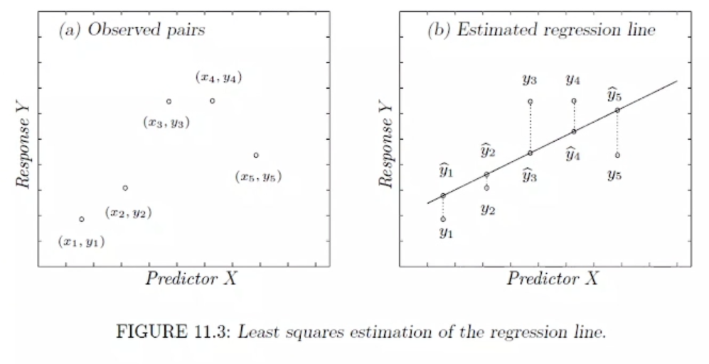

We are interested in how the dependent variable Y is changing so we look for vertical distance.

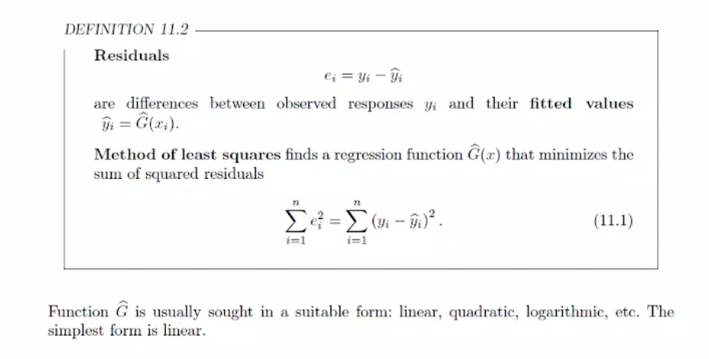

e (error) 🡪 difference between line and data point

With method of least square, we are gonna try to find the least square of distances.

We use square to prevent negativity.

LINEAR REGRESSION

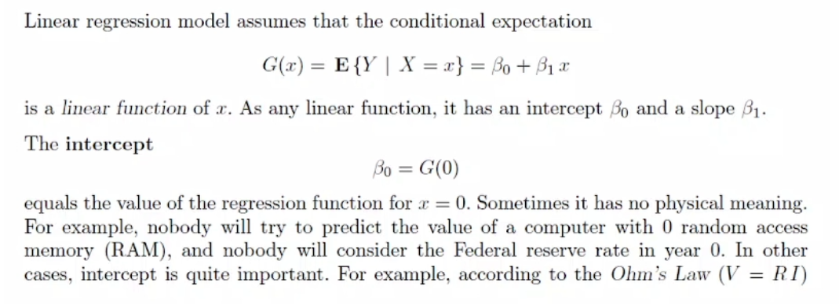

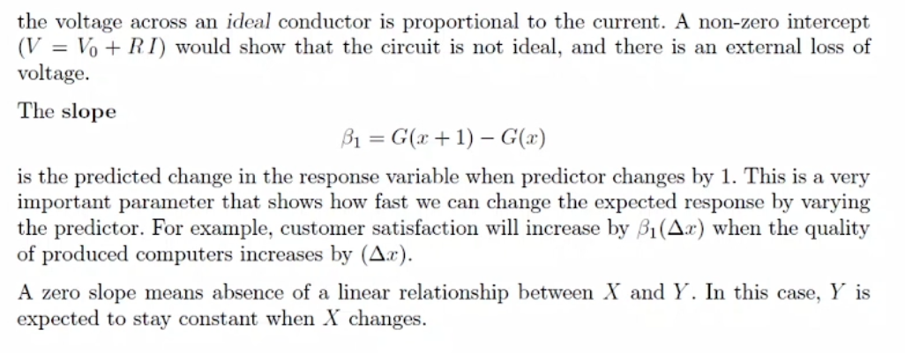

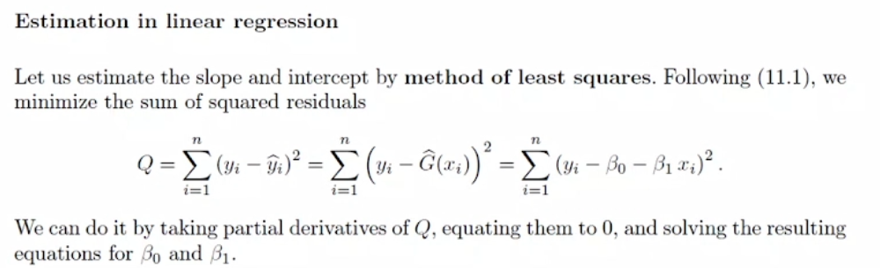

When derivative is 0, function has min or max points. Q is the function we are gonna minimize. We take its derivative and set it to 0.

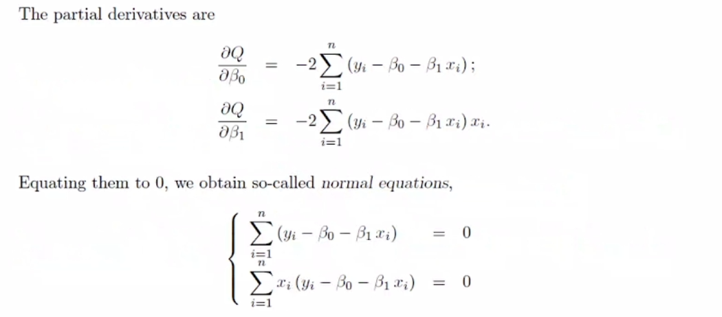

We are trying to find betas so we take derivatives according to them.

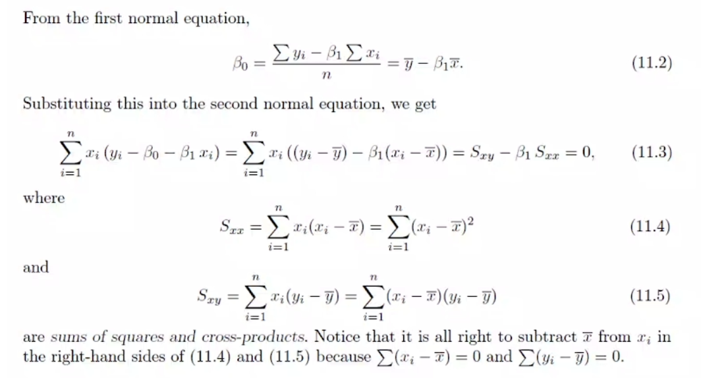

$\overline{y}$ and $\overline{x}$ are the mean.

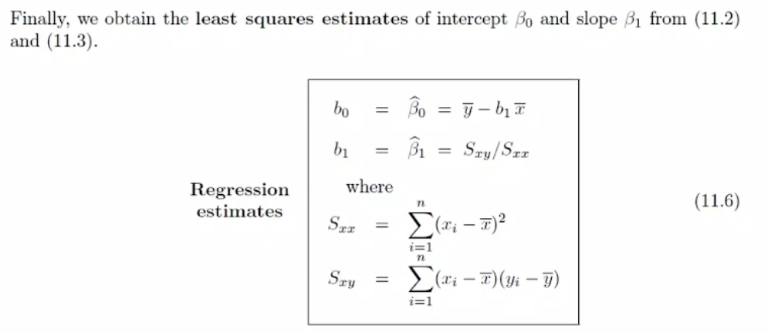

Example:

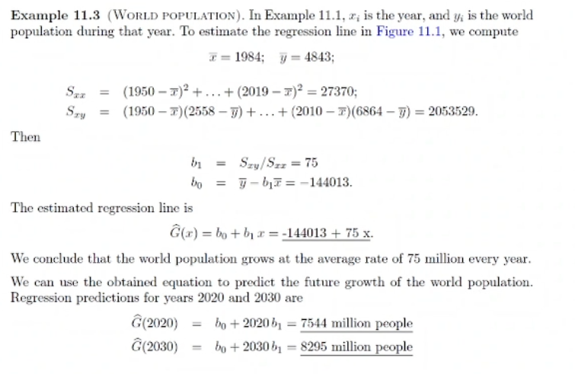

Regression and Correlation

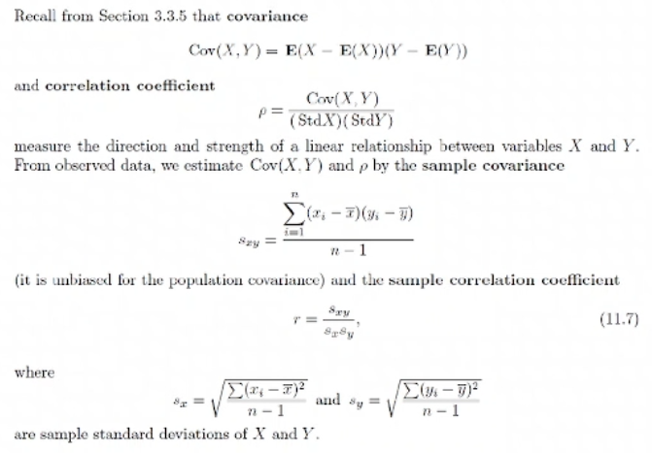

Covariance 🡪 relation between expected value of 2 different random variables

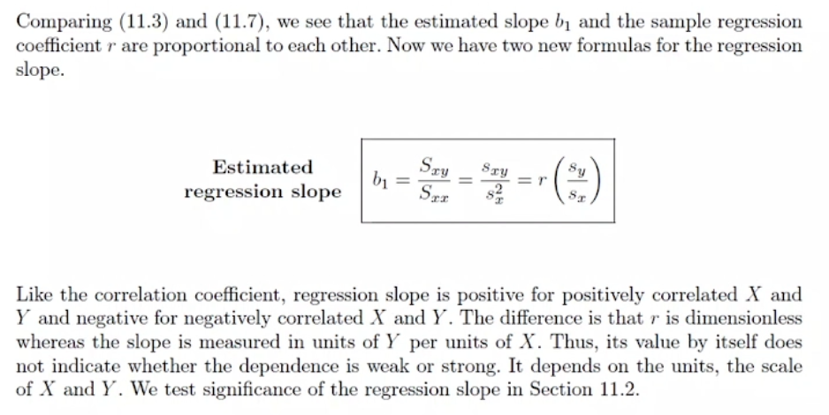

Standard deviation is distance between your prediction and data.

Overfitting

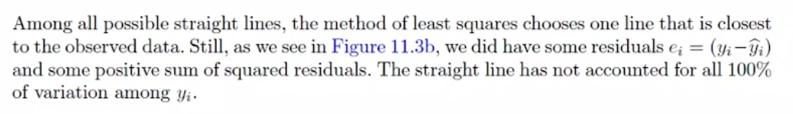

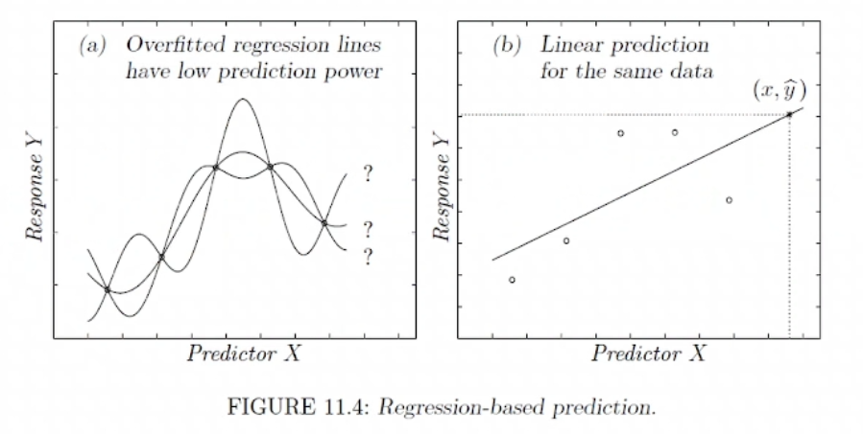

Overfitting in regression lines is not good.

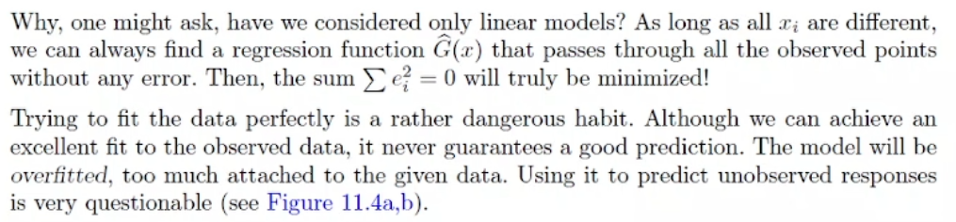

Simple Linear Regression

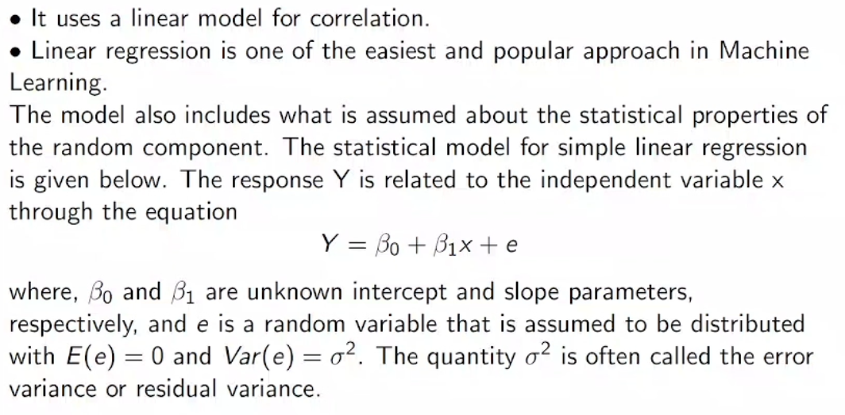

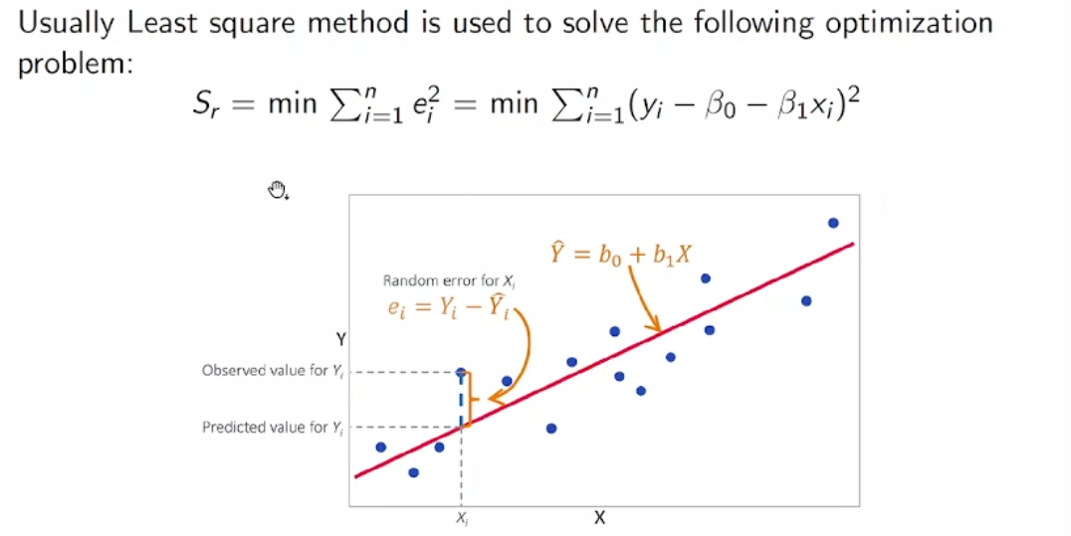

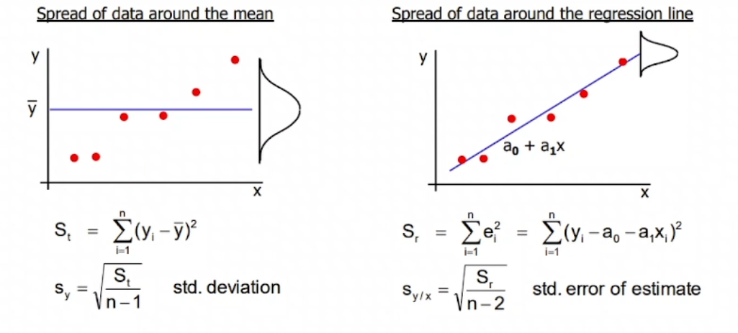

How good is the “best” line?

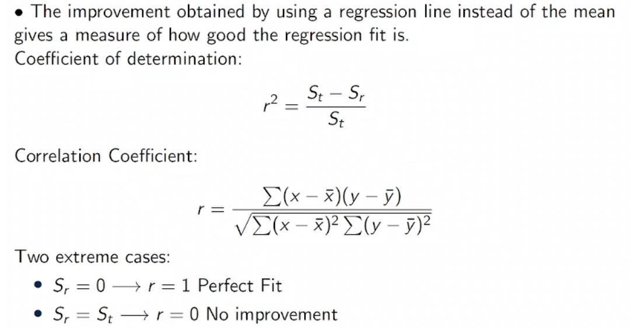

Non-linear cases:

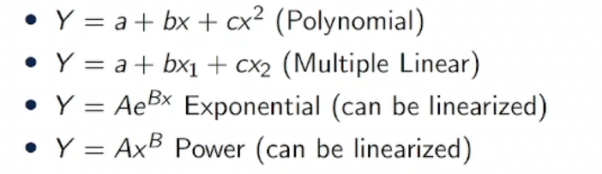

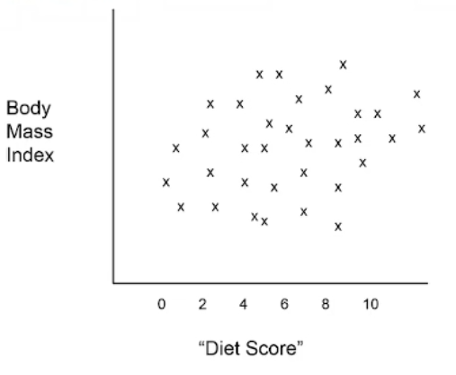

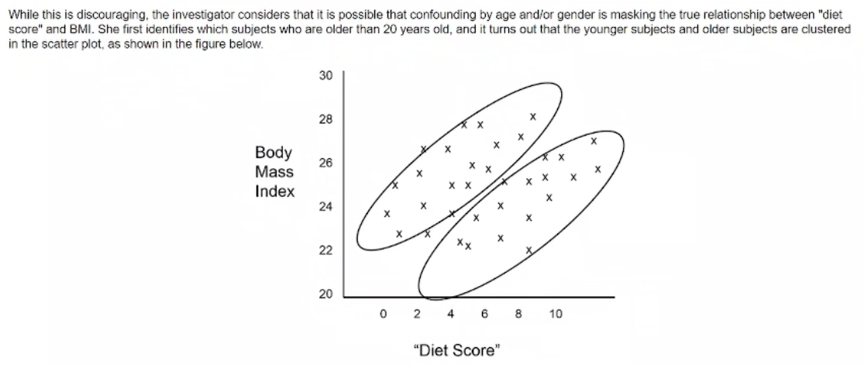

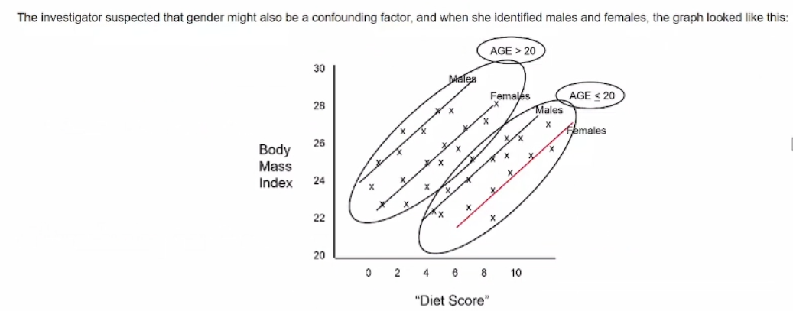

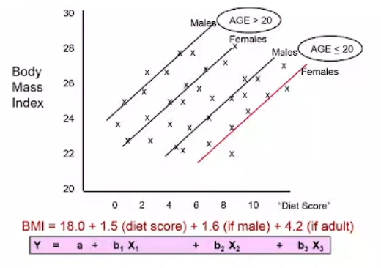

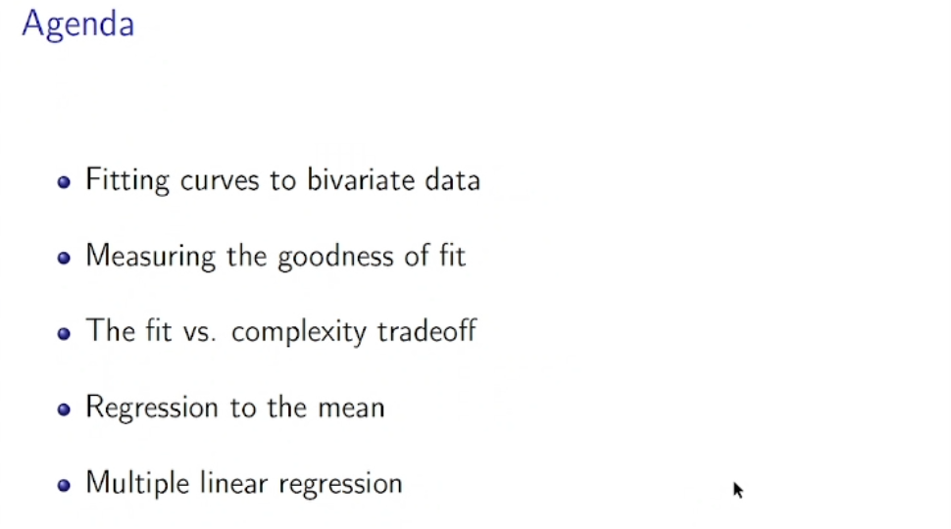

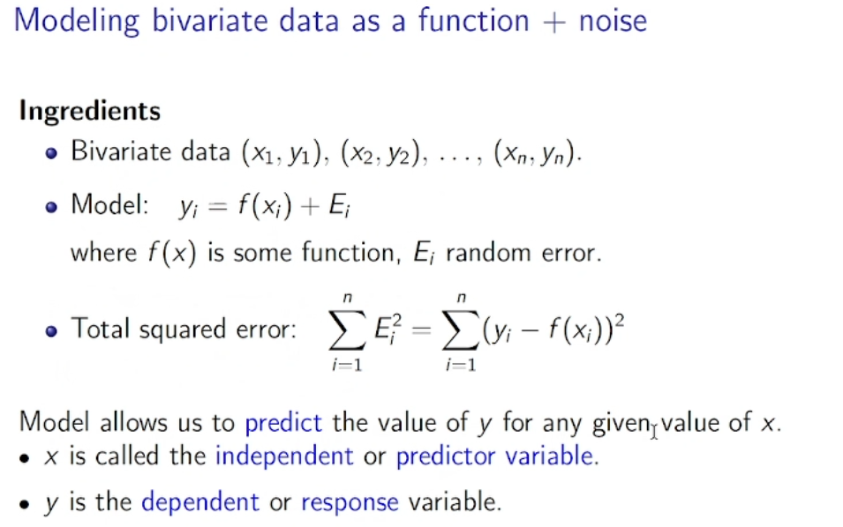

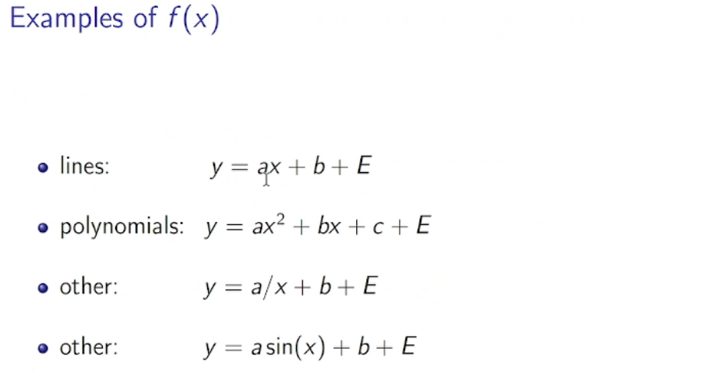

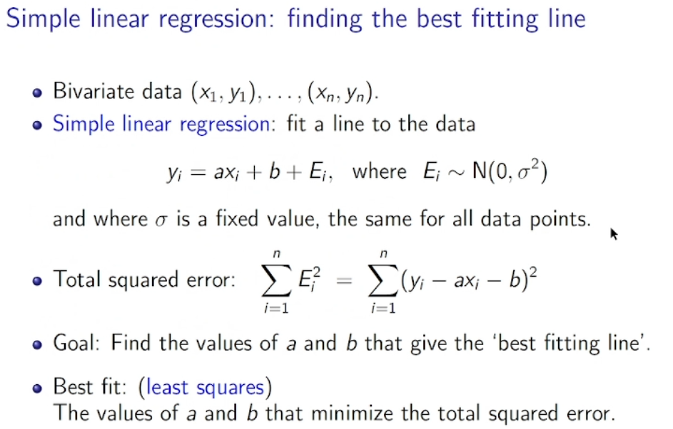

We want error to be normally distributed.

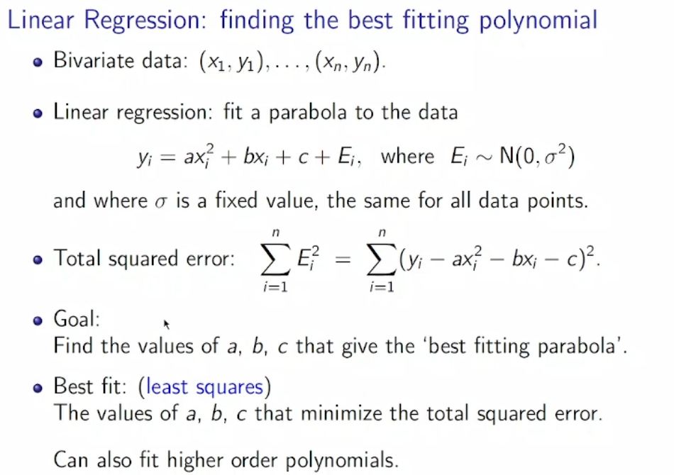

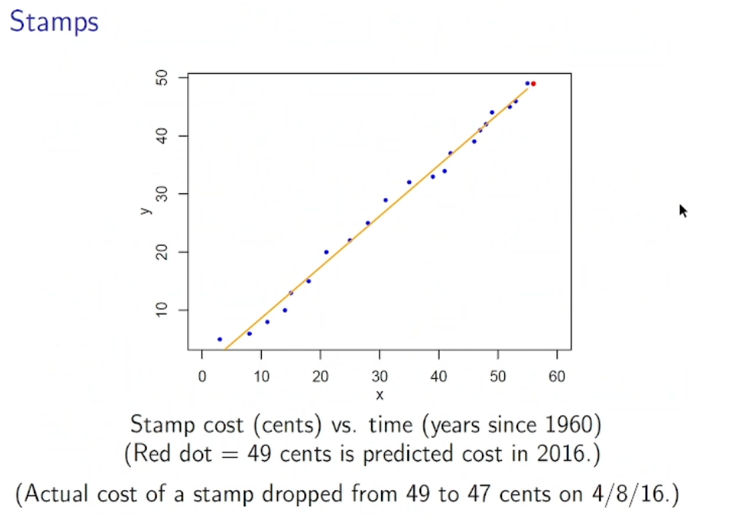

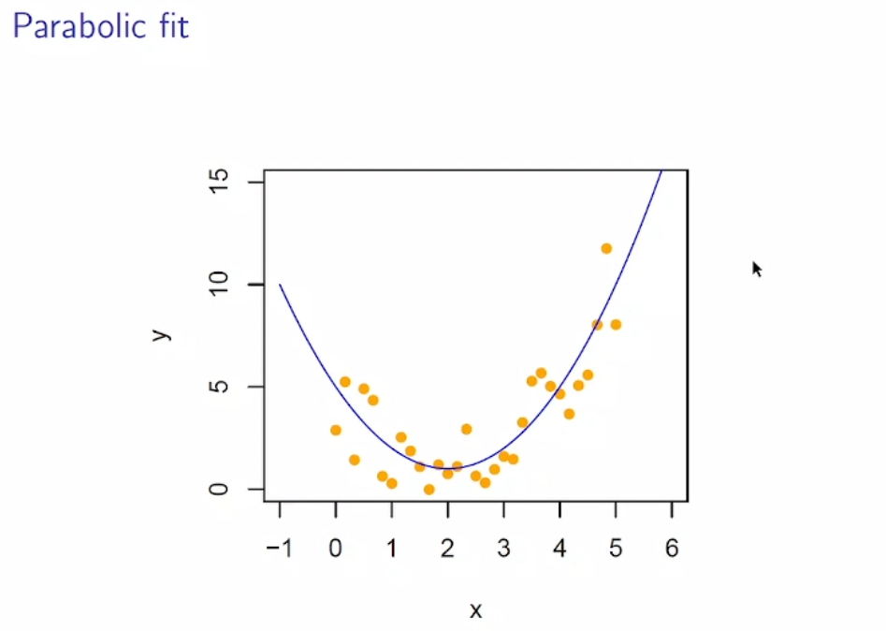

Example:

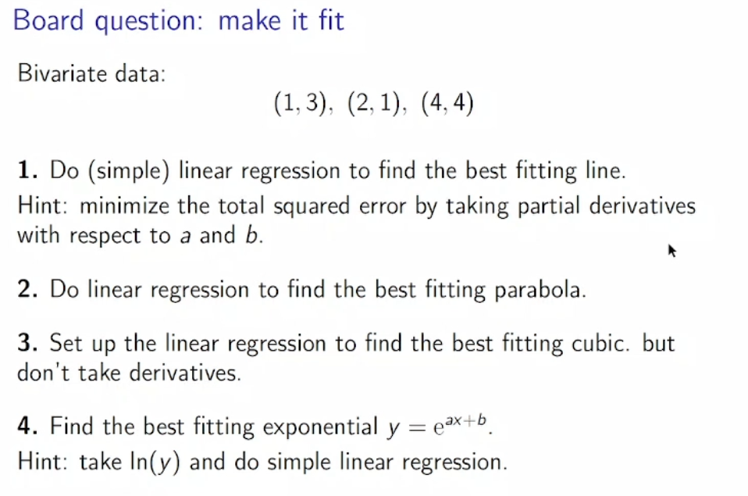

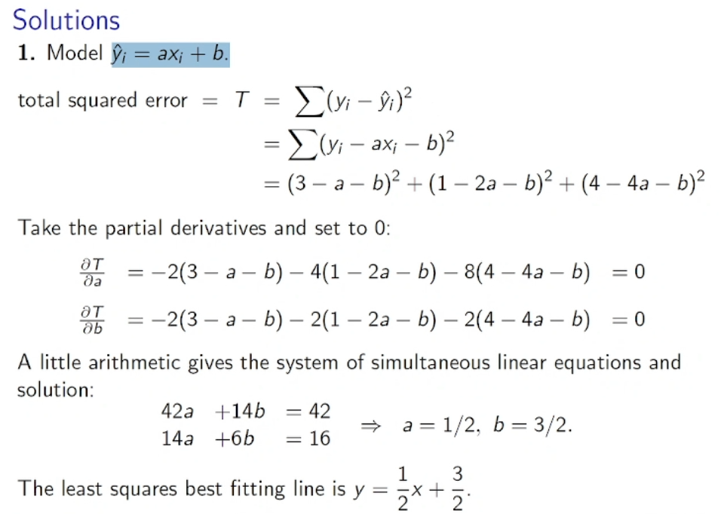

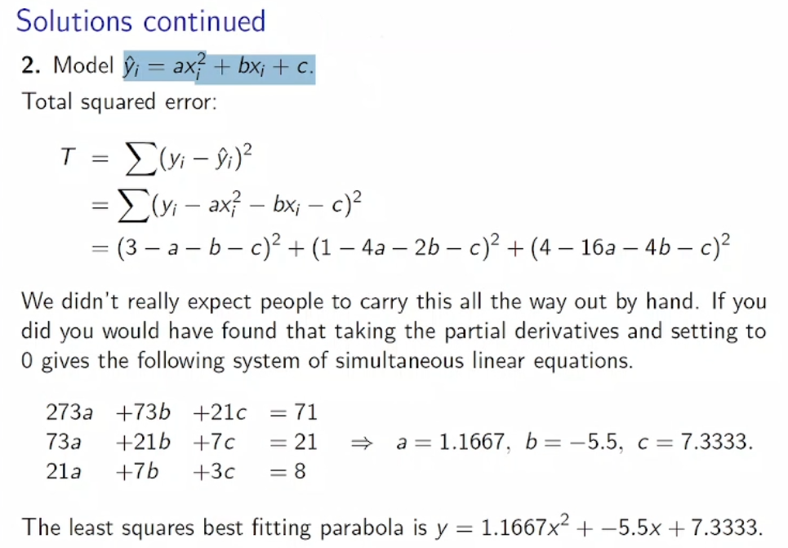

If you cant find a, b, and c then you can say there is no fitted data for these numbers.

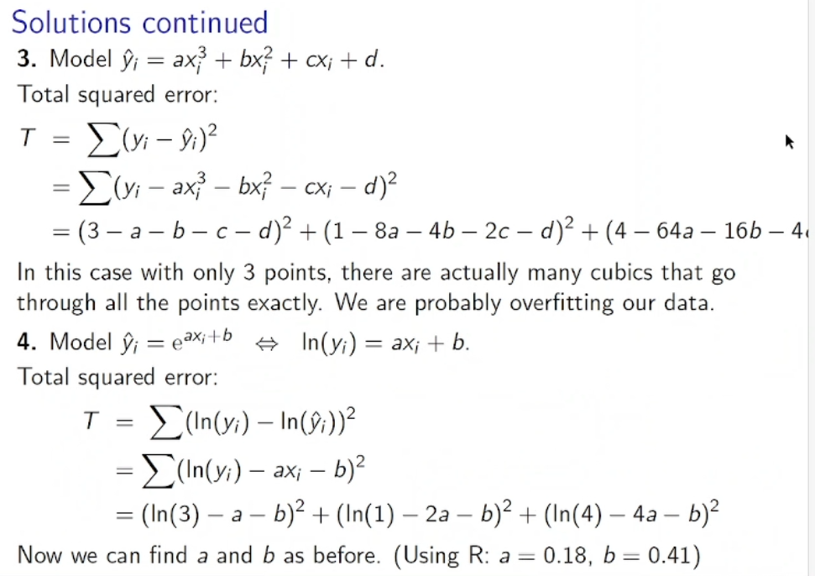

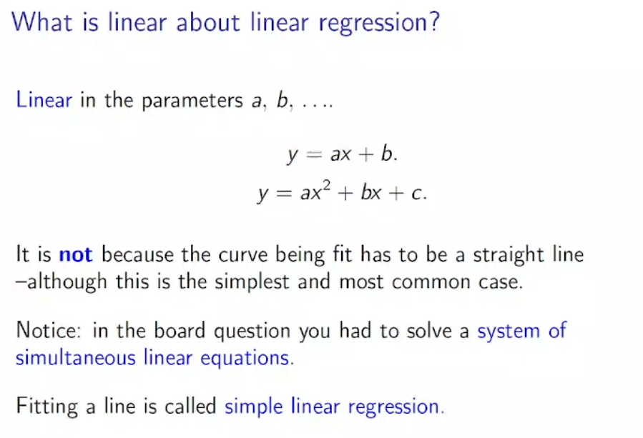

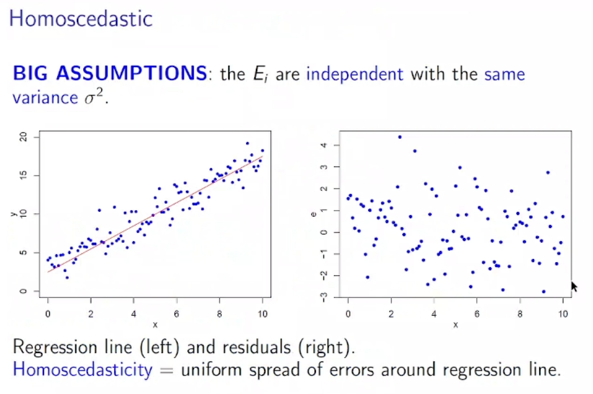

Error is distributed around line 0.

We want distribution around the line to be normal.

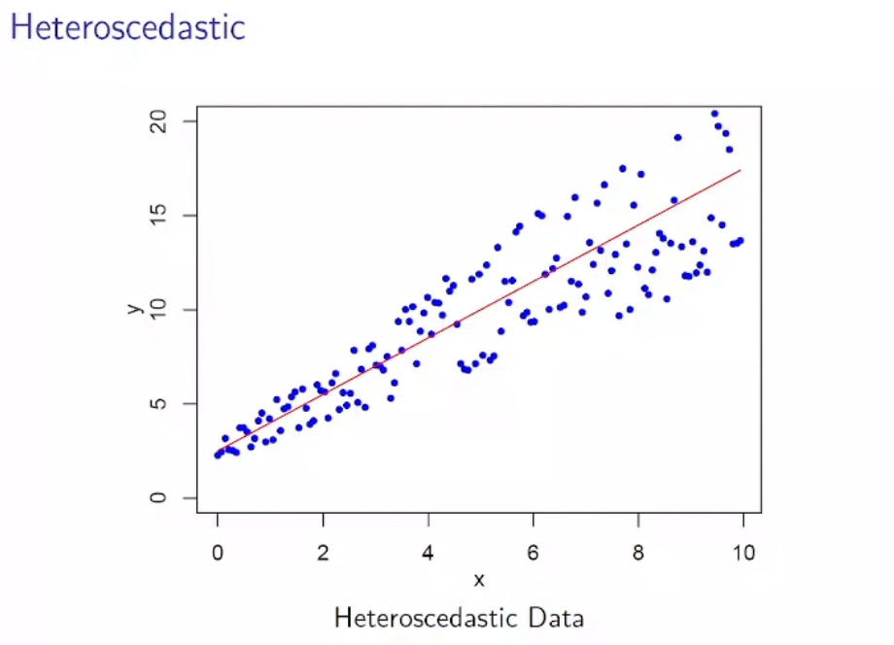

This is not good.

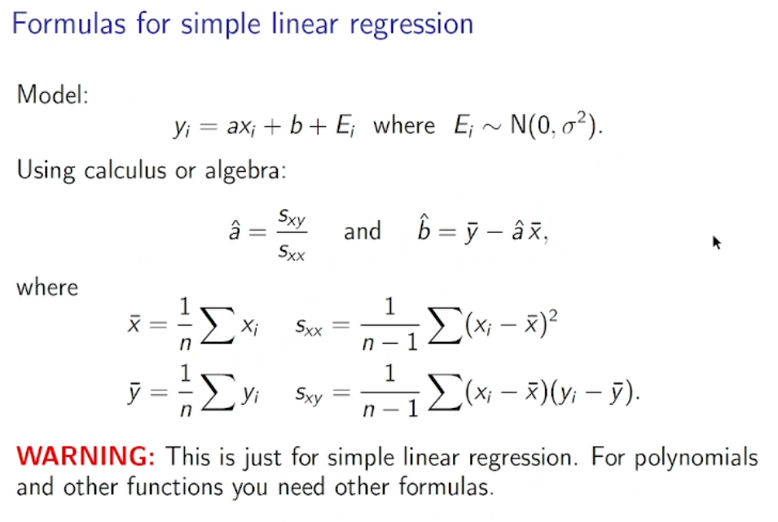

Example:

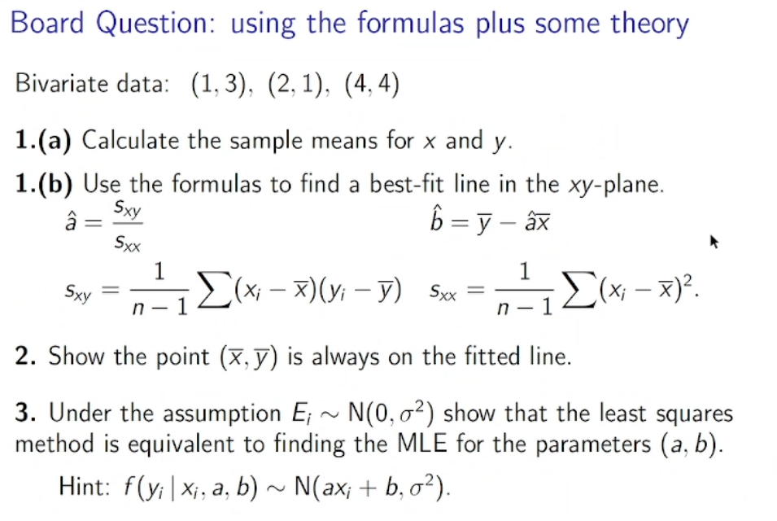

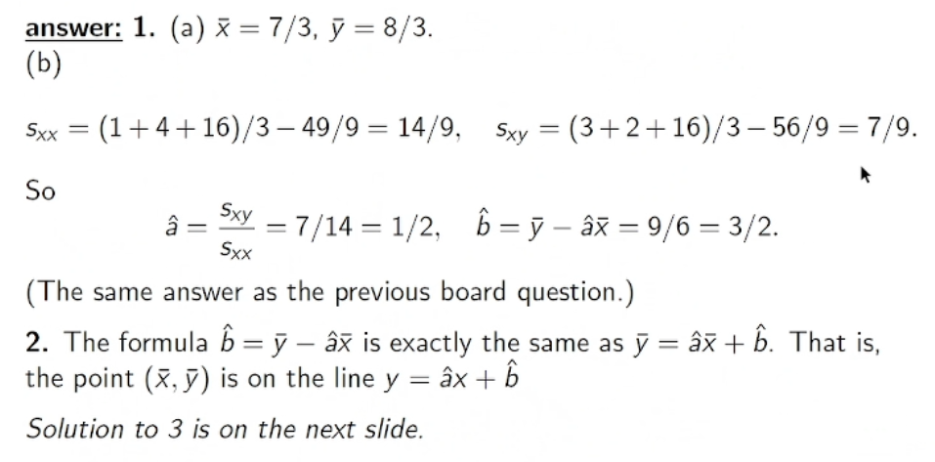

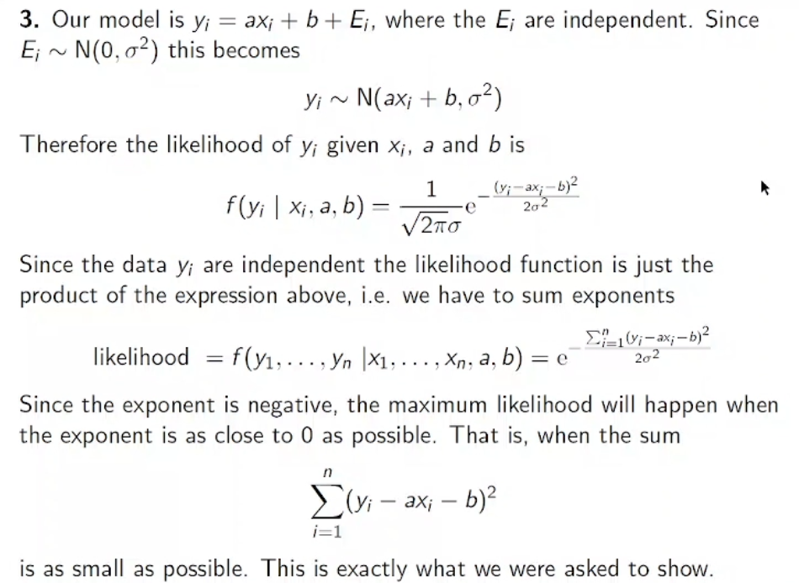

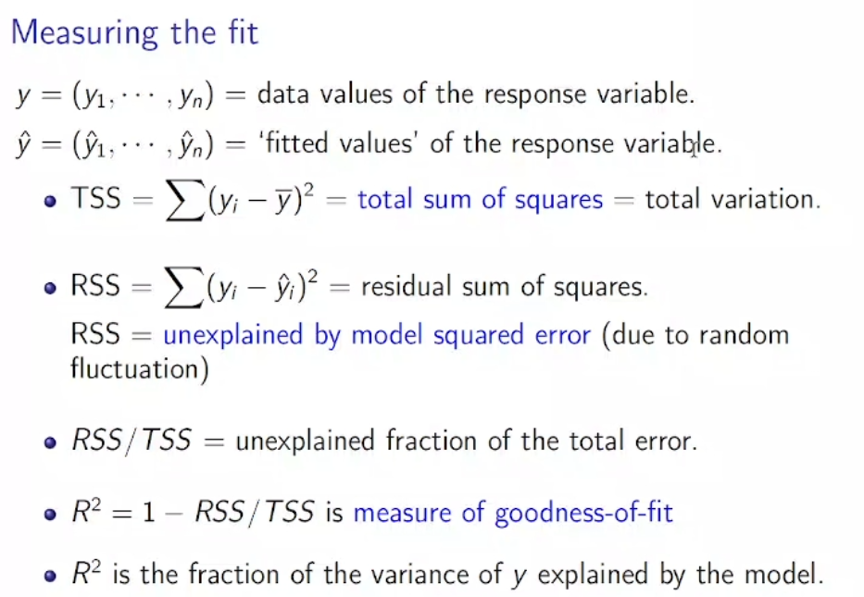

R is correlation coefficient.

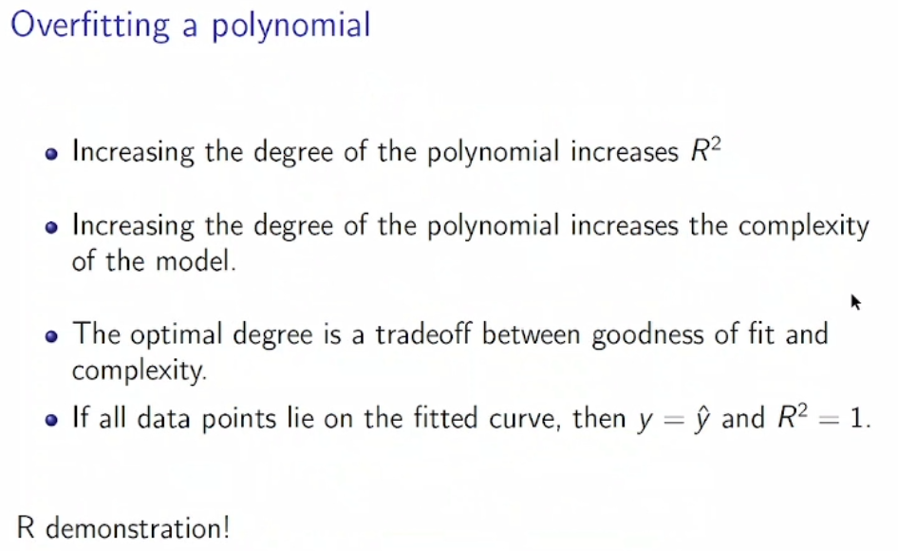

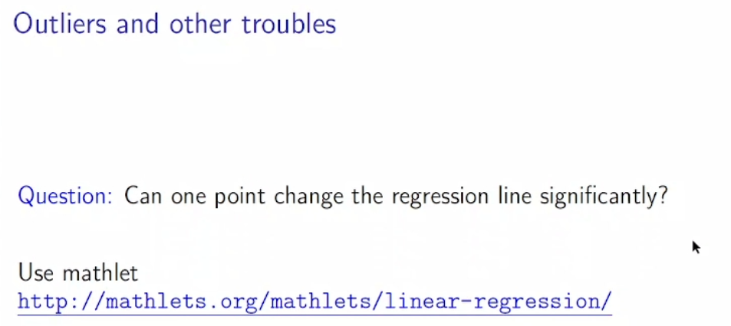

mathlets.org/mathlets/linear-regression/